EERM.
EERM extends the classic Entity Relationship Diagram (ERD) to capture more complex relationships and structures within an information system. It provides a comprehensive way to visualize and understand the entities, attributes, and relationships.
Types of EERM
Conceptual EERM Diagram:
Definition: A conceptual EERM diagram depicts the high-level entities, their attributes, and the relationships between them in a business domain.
Example: System for a library. In the conceptual EERM diagram, you'd identify entities like "Book," "Author," "Member," and "Borrowing." You'd also define the relationships between these entities – for instance, a book can be written by one or more authors, and each member can borrow multiple books.
Logical EERM Diagram:
Definition: A logical EERM diagram translates the conceptual model into a more detailed representation, including data types, keys, and normalization.
Example: Continuing with the library system example, in the logical EERM diagram, you'd specify details like the data type of each attribute (e.g., book title as a string, pub lication date as a date), primary and foreign keys to establish relationships between tables, and normalization to ensure efficient data storage and retrieval. You'd also refine the cardinality of relationships – for example, specifying that each book can have multiple authors, but each author can contribut e to many books.
Physical EERM Diagram:
Definition: A physical EERM diagram represents the actual implementation of the database, including table structures, indexes, and other physical design elements.
Example: Now, in the physical EERM diagram for the library system, you'd translate the logical model into the actual database tables, specifying details like column names, data types, constraints, and indexes. For instance, you'd create tables for "Book," "Author," "Member," and "Borrowing," with columns corresponding to their attributes. You'd also define primary and foreign key constraints to enforce data integrity, and indexes to optimize query performance.

Subtypes and Supertypes in EERM
In EERM, subtypes and supertypes are used to model hierarchical relationships between entities. A supertype is a general entity that has more specialized subtypes branching off from it. Subtypes inherit the attributes and relationships of their supertype, allowing for more detailed and nuanced modeling.

Disjoint Constraint:
In a disjoint constraint, an entity instance of a supertype can only belong to one subtype.

For example, consider a super class called ‘Account’ with subtypes ‘Savings Account’ and ‘Current Account’. In this case, a bank account can either be a Savings Account or a Current Account, but not both simultaneously.

Overlapping Constraint:
In an overlapping constraint, an entity instance of a supertype can be a member of multiple subtypes.
For example, consider a super class ‘Person’ with subtypes ‘Customer’ and ‘Employee’. In this case, a person can be both a customer and an employee simultaneously.

Advantage of enhance entity relationship model
Improved Data Modeling
EERM allows for more comprehensive and accurate modeling of complex entities, relationships, and business rules, leading to better data integrity and understanding.
Hierarchical Structures:
The EER model allows for the creation of superclass and subclass hierarchies, which help in organizing entities into more general or more specific categories.
Reusability:
Common attributes and relationships can be defined in a superclass and reused by all its subclasses, reducing redundancy.
Visualization:
EER diagrams provide a clearer and more detailed visual representation of the data model, making it easier for designers and stakeholders to understand and communicate the structure of the database.

Logical Database Design
Logical database arranging data in a structured way to ensure it can be efficiently stored, retrieved, and maintained. It involves defining tables, columns, and the relationships between them.

Integrity Constraints
Integrity constraints ensure the accuracy and consistency of data in the database.
- Domain Constraint: Specifies the permissible values for a given column.
  - Data Type Constraints: Ensure that data stored in each attribute matches the specified data type, such as integers, strings, or dates.
  - Range Constraints: Limit the acceptable values for an attribute to a specific range, such as ages between 0 and 120 or salaries between $30,000 and $150,000.
  - Enumeration Constraints: Restrict an attribute to a predefined set of valid values, like gender (male, female, other) or account status (active, inactive, pending).

- Entity Integrity: Ensures that the primary key value for every row is unique and not null.
  - Primary Key Constraint: Ensures that each tuple (row) in a relation (table) has a unique identifier, known as a primary key, to differentiate it from other tuples.
  - Uniqueness Constraint: Guarantees that the values of a specified attribute or set of attributes are unique across all tuples in a relation.
  - Not Null Constraint: Requires that an attribute cannot have a null value, ensuring that every tuple has a non-missing value for that attribute
Example: Each student must have a unique StudentID, and it cannot be empty.
- Referential Integrity: Ensures that a foreign key value always points to an existing record in another table.
Example:
If StudentID in the Enrollments table refers to StudentID in the Students table, referential integrity ensures that you can't add a record in Enrollments with a StudentID that doesn't exist in the Students table.

Data mining
Data mining is the process of extracting valuable insights and patterns from large, complex datasets. Data mining enables organizations to gain a deeper understanding of their data and unlock new business opportunities.

Data warehouse
A data warehouse is a centralized repository that stores large volumes of structured data from multiple sources,

OLAP (Online Analytical Processing)
OLAP (Online Analytical Processing) is a technology that enables fast and efficient analysis of data stored in a database.
OLAP enables users to explore and analyze multidimensional data from various perspectives. It allows for the quick and flexible querying and manipulation of large datasets.

OLTP (Online Transaction Processing)
OLTP systems are designed to handle high-volume, low-latency transactions in real-time. They focus on efficiency, consistency, and reliability for mission-critical business operations like order processing, banking transactions, and inventory management.
XXX

Strong Entities:
A strong entity is an entity that can exist independently of any other entity. It has its own unique identifier (or primary key) that distinguishes it from other entities.

Weak Entities:
A weak entity is an entity that cannot exist without being associated with a strong entity. It doesn't have its own unique identifier; instead, it relies on a foreign key which is linked to a strong entity.
Example in Real Life:
Consider a Bank Account as a weak entity. A bank account cannot exist without being associated with a person (a strong entity). The bank account number alone is not enough to uniquely identify an account; it needs the person's identifier (e.g., SSN) to do so.

Types of Entities:
- Identifying Attributes - These are the unique characteristics that distinguish one entity from another, such as a customer ID or a product SKU.
- Descriptive Attributes - These provide additional details about an entity, such as a customer's name, product description, or order date.
- Derived Attributes - These are values that can be calculated or inferred from other attributes, like a customer's age based on their date of birth or a product's total sales based on individual order quantities.

Cardinality
Cardinality defines the numerical relationship between an entity. It specifies the minimum and maximum number of attribute instances associated with each entity.
Multiplicity
Multiplicity describes the possible number of relationships an entity can have with another entity.

Specialization: Dividing entities into sub-entities we called as specialization.
Generalization: combining sub-entities to one entity is called a generalization.
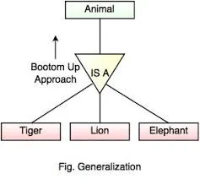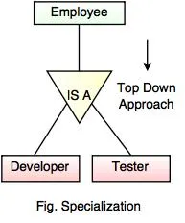

Total participation
If all members in the superclass(main entity) participate in either one subclass it is known as total participation. It marks by double lines.
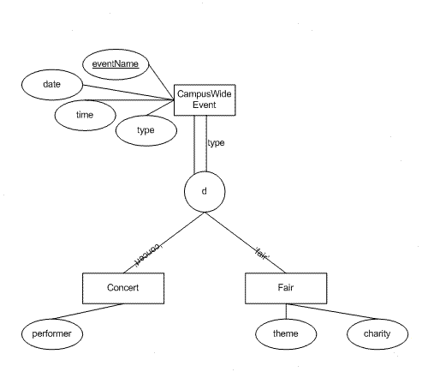

Partial participation.
If at least one member in the superclass does not participate in subclass it is known as partial participation. It is denoted by one single line.
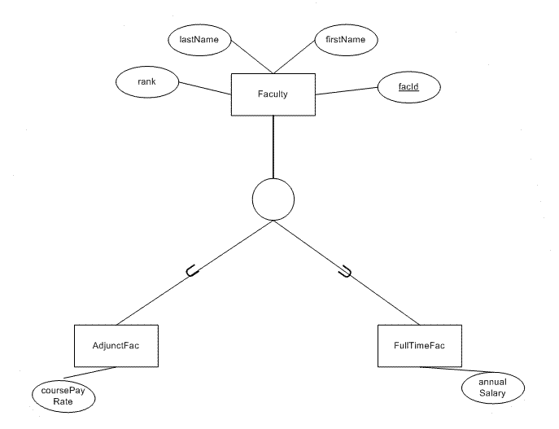

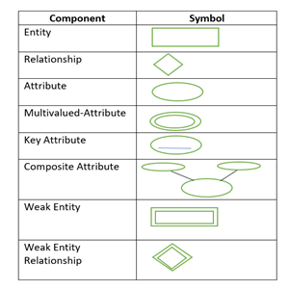

A relation that is in First Normal Form and every non-primary-key attribute is fully functionally dependent on the primary key, then the relation is in Second Normal Form (2NF).

